Cat Colony Management
Best Practices
"When cat populations are present, the choice is not between having
cats and not having cats. It's between having a managed colony and
CITY OF TEMPE
an unmanaged colony.”
-Brian Kortis, Program Manager, PetSmart Charities

Best Practices for Cat Colony Management
(as recommended by the Humane Society of the United States)

TNR (Trap-Neuter-Return) – Neutering an entire cat colony stops population growth and allows for ID of friendly cats and kittens to be adopted. Neutered cats roam less and are less likely to fight or mark territory, meaning fewer complaints of noise or destructive behavior. Cats will also “hold” the territory and keep the majority of new (unneutered) cats from moving in and breeding, maintaining a stable population. (TNR’d cats can be identified by the flattened tip of the left ear, clipped during surgery.)

Controlled feeding – A designated place and time for feeding puts cats on a schedule, making them easier to trap and less predatory. Without controlling the food, we can never control the cats.

Tracking your colony – Keeping track of colony members along with their overall health and spay/neuter status is key to good management. Identification of owned cats in the neighborhood avoids wasting resources trapping cats who are already fixed. Tempe tracks colonies in 57 zones across the city.

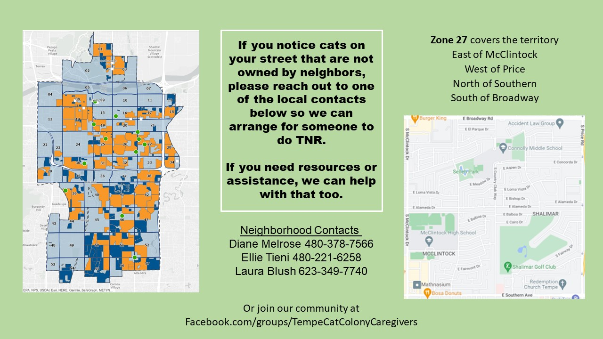
Community Cats:

Frequently Asked Questions
CITY OF TEMPE

Why is Tempe investing in feral cats?
With as many as 70 million outdoor cats in the U.S., every neighborhood is contending with this problem. Without intervention, the cat population will continue to increase, but your well-meaning neighbors are unable to fully manage and control the cats by themselves.

Why can't we just get rid of the cats?
There is literally nowhere for them to go. Virtually every U.S. neighborhood has its own cat population. Cats are territorial and will generally return to their original home if moved, but even if cats are successfully relocated, neighboring cats would move quickly to expand into the territory and take control of available resources. New cats may not be neutered, leading to rapid population growth. Additionally, outdoor cats are protected by state law and relocating them by abandoning them somewhere else is a felony.

Can't we make feeding feral cats illegal?
Many cities have tried with no success. Not feeding cats does not make cats leave their home territories, they simply become more aggressive hunters and scavengers, keeping them closer to our homes.

Won't feeding all these cats just bring more cats into the neighborhood?
No. If cats are fed appropriate amounts and food is not left out, there will be no draw for neighboring animals. The cats who live here now will "hold the territory" and stop most new cats from moving in. The key is to provide just enough food for the existing cat colony.

But won’t they just keep breeding?
Successful colony management includes Trap-Neuter-Return (TNR) of all cats. The cats are neutered and then returned to their home territory to continue keeping unneutered cats out. The City of Tempe funds these TNR services for residents managing cat colonies in their neighborhoods.

How do I keep cats off my property?
Residents have reported positive results with a variety of deterrents including motion sensor sprinklers, ultrasonic devices, specialized mats, fencing, and sprays. Additionally, providing appropriate toileting areas, shade structures, and other incentives can encourage cats to settle in more appropriate parts of the neighborhood.

What resources are currently available?
Educational materials and funding for TNR surgeries are currently available to colony managers. Residents struggling with negative cat behaviors or colony managers in need of assistance may contact kristin_gwinn@tempe.gov.

